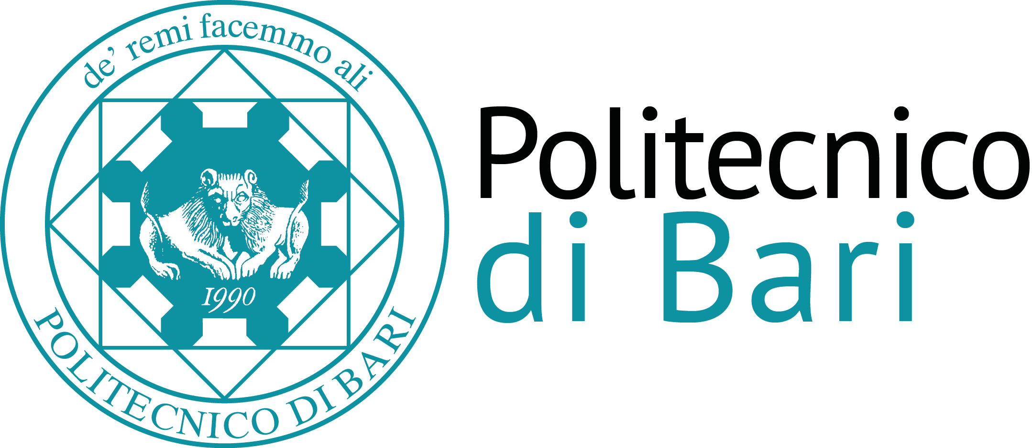

Scuola di Dottorato del Politecnico di Bari

Ph.D. School

Adaptive technologies for the Mitigation of Urban Heat Island and Climate Change Effects
CFU 3 (24 ore)
SSD: ICAR/10
Goal. The aim of the course is to provide students with the knowledge of the effects of climate change and Urban Heat Island (UHI) on built environment. The course will also provide detailed knowledge on the techniques and technologies to adapt the building fabrics to the effects of climate change and UHI and to counterbalance the temperature increase.
Program. The first part of the course will explore in details the major issues of urban climatology, helping in defining the interaction between environmental variables, outdoor surfaces and building fabrics. In the second part of the course detailed students will investigate in detail adaptive technologies to mitigate the temperature effects of climate change-related phenomena. Examples from successful real case studies will be shown. Finally, the third part of the course will provide students with a hands-on experience of modelling techniques and tools to simulate the thermal characteristics of cities and buildings and assess the impact of adaptation technologies. The assessment will be based on the modelling of a selected case study and on the analysis of the effects of different adaptation technologies.

