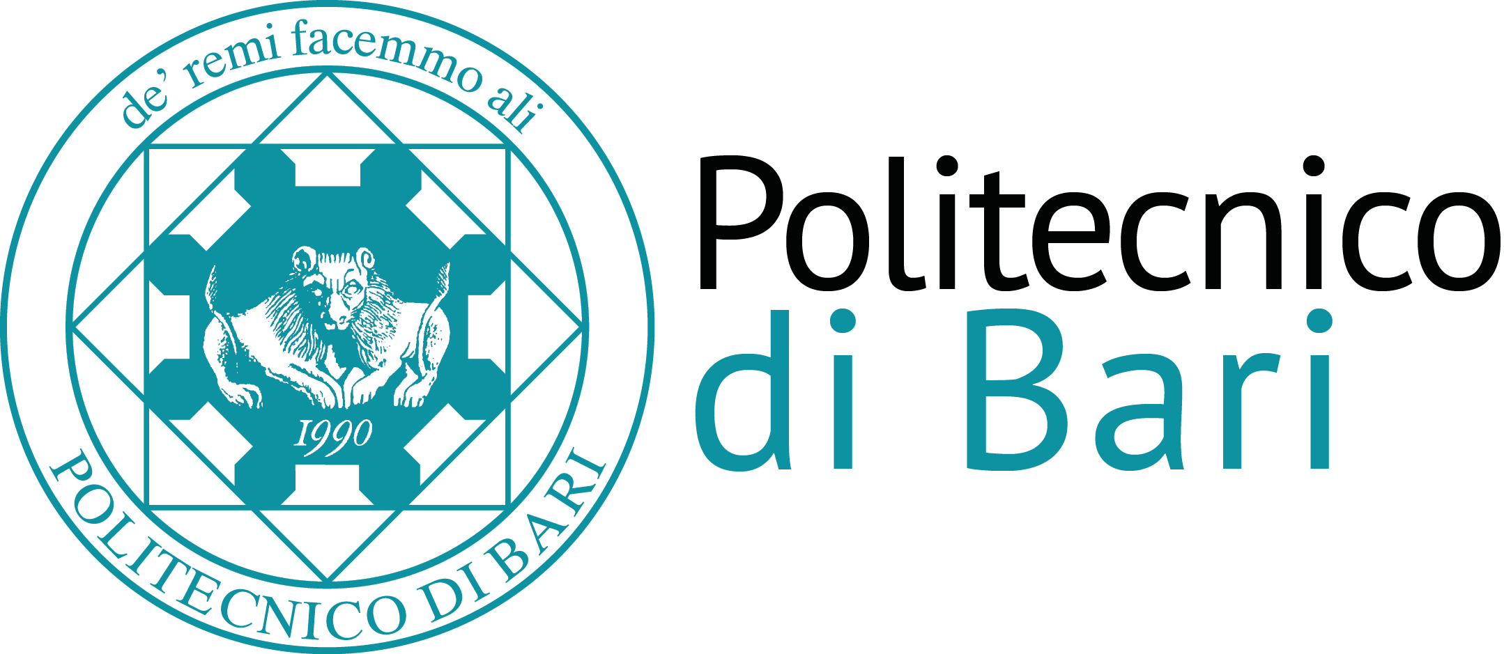

Scuola di Dottorato del Politecnico di Bari

Ph.D. School

Green products and processes

CFU: 3 (24 ore)

SSD ING-IND 35, Ingegneria economico gestionale
Topic | Teaching method | Hours
Ecosystem and Economic system: environmental input-output analysis as a tool to measure flows between the two systems. | Lecture | 4
Ecosystem and Economic system: environmental input-output analysis as a tool to measure flows between the two systems. | Numerical applications (MS Excel) | 4
Sustainable development, sustainability reporting, and stakeholder theory. | Lecture | 4
Multi-Attribute Group Decision Making (MAGDM) techniques as support for sustainability reporting. | Lecture and numerical applications | 4
Materiality analysis for a business through MAGDM techniques. | Business case. | 4
Life Cicle Assesment. | Lecture + Business case (SimaPro or other LCA SW) | 4

