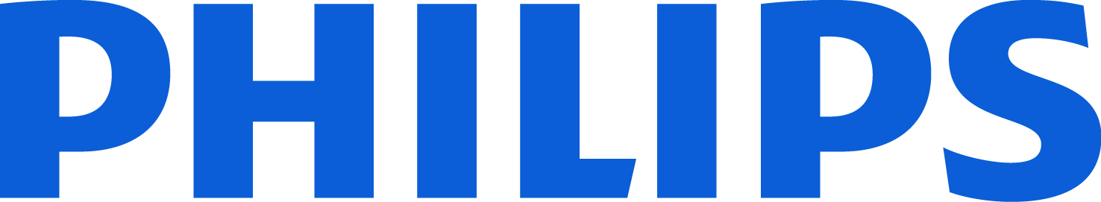
To exceptional students and recent graduates we are offering different challenging internship opportunities for graduates in engineering, and specifically mechanical engineering. Working with Philips means working with engineering excellence and innovation on the highest level. Designing, developing and testing technical solutions and applications, will have the opportunity to work directly with in one of the most professional, meticulous and high-profile engineering teams anywhere.
Desired Skills and Experience
In order to succeed in this challenging internship, you will ideally have achieved excellent academic results in the area of mechanical engineering.
You have gathered work experience through internships or projects that allow you to understand the complexities of the environment outside of university and helped you to develop your personal and communicative skills. In Philips you must exhibit the capability to think analytically, target-oriented and structured. You need to demonstrate strong communication skills (such as the ability to listen as well as in-depth reasoning). You will be expected to work independently as well as integrate as part of a team. We require attention to the detail and awareness of the responsibility that comes with your role.
You are motivated to adapt to and learn from the company culture. It goes without saying that you relish a challenge. The effective completion of your daily tasks requires you to be a proficient user of Microsoft Office (Word, Excel, PowerPoint & Outlook). Advanced knowledge of engineering programs such as Team Center, DAP SAP, CAD (NX Unigraphics) is a plus and help you to successfully master your daily projects. Fluent English is a must-have while a good level of Italian is an advantage for your best local integration. Philips specifically appreciates individuals with experience outside their country of origin, allowing for a multicultural mindset. These internships require fulltime attendance at Philips Saeco in Gaggio Montano (BO), Italy.
In return, we offer you
You will be part of the New Product Introduction team located in Gaggio Montano. You will work within BG Coffee, part of Healthtech Personal Health, which creates innovative and superior full automatic espresso coffee machines that has been designed to bring a great coffee experience at home and enable delicious coffee to be easily made.
Working at Philips is more than a job! It is a calling to create a healthier society through meaningful work, focused on improving 3 billion lives a year by delivering innovative solutions across the health continuum. Our people experience a variety of unexpected moments when their lives and careers come together in meaningful ways. To find out more about what it’s like working for Philips at a personal level, visit the Working at Philips page on our career website, where you can read stories from our employee blog. Once there, you can also learn about our recruitment process, or find answers to some of the frequently asked questions.
Please apply to www.philips.com o mail a: giuseppe.basile@philips.com
Deadline 15 marzo 2018

