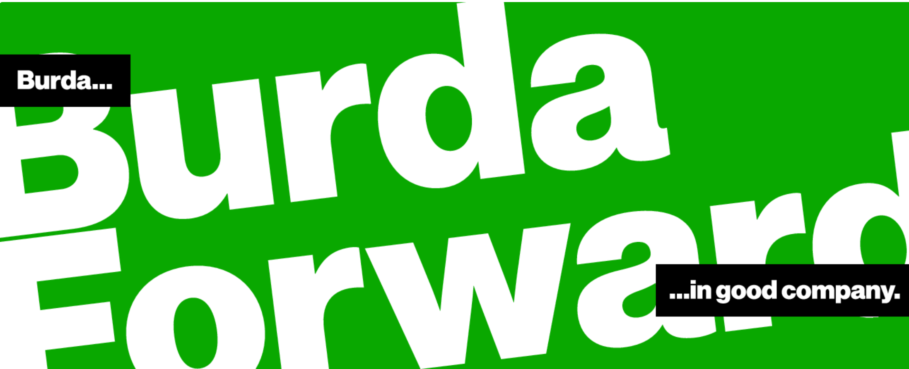

Solution Architect (m/f/x) at BurdaForward Italia
BurdaForward is the digital media house of the future. Our strong network is based on the journalistic brands Focus Online, Chip, Finanzen100, NetMoms, The Weather Channel, Efahrer and Cardscout. We already inspire more than every second internet user in Germany (agof daily digital facts April 2019) and we combine first-class journalism with innovative technology!

What you can expect from us...
- You´ll be working on a product and not projects
- You´ll be responsible for designing and implementing the backbone of our new publishing platform
- This is a hands-on position: you´ll develop new features and services in close collaboration with the product owner and the development team
- You´ll contribute, communicate and cooperate closely across all BurdaForward teams, such as the other platform Development Teams, Operations and Data Science
- You´ll consult other development teams and guide junior developers

What we would expect from you...
- You have at least 5+ years of working experience in designing and developing backend applications and cloud architectures
- You have a deep knowledge of state-of-the-art backend technologies, such as serverless frameworks (AWS Lambda), node.js and other JS frameworks
- You have solid knowledge of cloud services and technologies (AWS preferred)
- You have great expertise in NoSQL and SQL Databases, RESTful API, JSON, XML, microservices, web protocols, event driven architectures, high-performance and low latency applications
- You have experience with native cloud development (AWS), CI/CD, auto scaling, infrastructure as code
- You can speak and write in English fluently and enjoy working in an international environment
- You have an Italian work or residence permit

What we can offer you...
- Smart Working - we believe in flexibility when it comes to choosing where you deliver top-notch work
- A permanent employment contract with a competitive RAL
- International spirit with nearly 700 employees from over 32 nations across all our locations! English will be your primary working language
- We Care! We provide lunch vouchers, fruits, water and coffee in all our offices
- A sunny office located in the center of Bari with a large terrace
- We have flat hierarchies and encourage an open and direct communication

Contact HR Bari :
Phone +39 339 773 22 03
Mailto : bari@burda-forward.de Deadline : 01.12.2020

Senior iOS Developer (m/f/x) at BurdaForward Italia

BurdaForward is the digital media house of the future. Our strong network is based on the journalistic brands Focus Online, Chip, Finanzen100, NetMoms, The Weather Channel, Efahrer and cardscout. We already inspire more than every second internet user in Germany (agof daily digital facts April 2019) and we combine first-class journalism with innovative technology!

What you can expect from us...
- You are responsible for the development of our Finanzen100 iOS app and website – one of the most popular finance portals in Germany
- You´ll engineer and design software components in close collaboration with UX, Design, Product Management and of course your co-developers
- You´ll be working on a product and not on projects
- Our goal is to create products that not only work but are fun to use
- We see stability and performance as the basis of our products

What we would expect from you...
- You have experience in developing iOS apps in agile development processes
- You have good knowledge of Objective-C, Swift and all common frameworks and tools (iOS SDK, Co)
- You always stay up to date about the current tech around the iOS development
- You have a proven track record of published high quality apps
- You have good knowledge of the Human Interface Guidelines and app Store Review Guidelines
- You like to take responsibility and commitment for the products and services you´re developing
- You can speak and write in English fluently and enjoy working in an international environment
- You have an Italian work or residence permit

What we can offer you...
- Smart Working - we believe in flexibility when it comes to choosing where you deliver top-notch work
- A permanent employment contract with a competitive RAL
- International spirit with nearly 700 employees from over 32 nations across all our locations! English will be your primary working language
- Possibility to attend our English and German courses
- We Care! We provide lunch vouchers, fruits, water and coffee in all our offices
- A sunny office located in the center of Bari with a large terrace
- We have flat hierarchies and encourage an open and direct communication

Contact HR Bari :
Phone +39 339 773 22 03
Mailto : bari@burda-forward.de Deadline : 01.12.2020

